
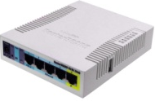
TOPOLOGI
192.168.absen.xx
192.168.absen.1
192.168.100.254
192.168.101.254
Lokal IIX
International IX

